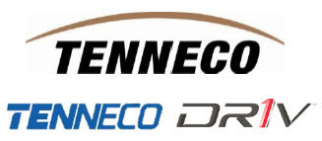

Dear Valued Supplier,

This notice is to remind you that on Friday 9-AUG at 12:00 AM ET (00:00 Hrs) many supply chain related systems and applications will be unavailable due to IT Application Splitting activities.  Specifically, this means that the following applications will be unavailable on 9-AUG, and will remain unavailable through the weekend.  When the systems are brought back up on late Sunday or Monday morning, the DRiVTM company will have new, separate versions of the following applications:

* The Tenneco Supplier Portal (TSP) will be cloned.
  + <https://dsp.driv.com/irj/portal> for **DRiV** *\*this site will not be available until 12-AUG*
  + <https://tsp.tenneco.com/irj/portal> for **TENNECO**
* Tenneco SNC will be copied to create a DRiVTM SNC (accessed through DRiVTM Supplier Portal at the link above)
* Tenneco SRM/TITAN will be copied to create a DRiVTM SRM/TITAN (accessed through DRiVTM Supplier Portal at the link above)
* Tenneco QIM/eMRR will be copied to create a DRIVTM QIM/eMRR (accessed through DRIVTM Supplier Portal at the link above)

Important Notes:

* **\*\*The above changes will be in effect for DRiVTM suppliers that ship to DRiVTM plants\*\***
* **Both Tenneco and DRiV™ users must cease ALL usage in SNC, TITAN, and eMRR/QIM 2-hours prior to the shutdown – 10 PM ET on Thursday, August 8. This means NO inbound ASNs, NO PPAP responses, NO Bid responses, NO eMRR responses.**
* User IDs for the above-mentioned systems will not change; users will continue to use their current IDs. However, a password reset may be required **for the NEW URL (www.dsp.driv.com) ONLY. Should the password reset function fail, please email titanpwreset@tenneco.com.**
* As communicated previously, the address for invoices for DRiV™ locations in the US and Canada has changed.

For Invoices to the US and Canada:

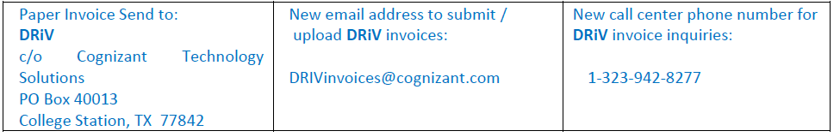

Thank you for your patience and understanding as we make this transition.

Sincerely,

Tenneco, Inc.